Abe, Lhudymuel I.

IT 3301

**Exploration 01**

**Installation of Git**

**Visit the** [**https://git-scm.com/**](https://git-scm.com/) **for the installation**

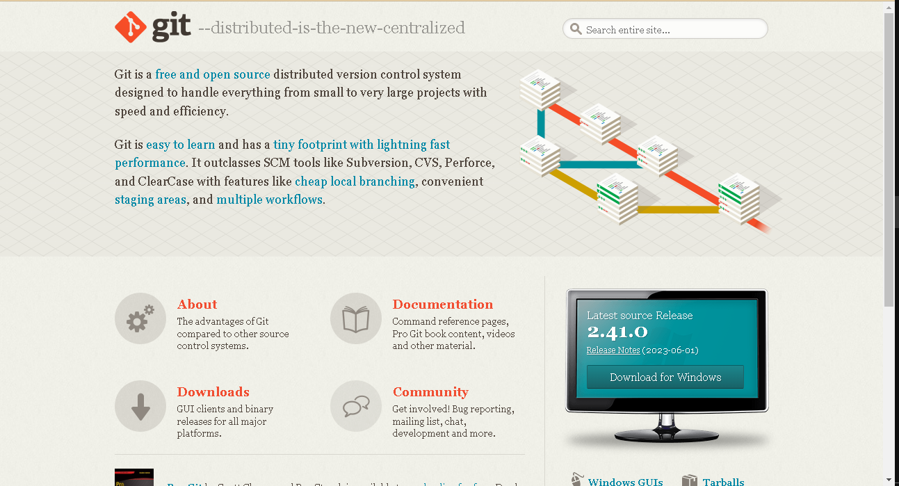

**Download Git**

